
Method 1
Using the exact function like following
=exact(column1, column2) This is only take two rows or columns
This method is case sensitive (see 1st row) 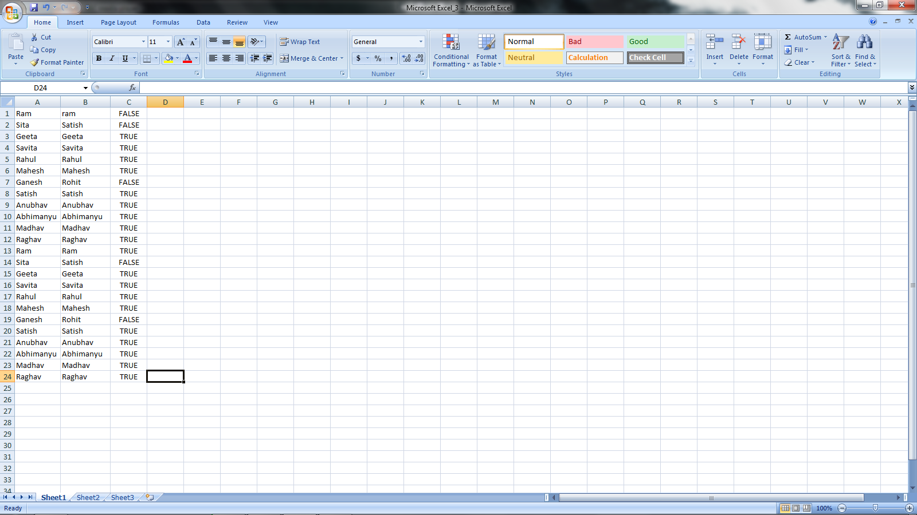
Method 2:- It is not case sensitive
- Select all rows and columns
- Go to ‘find and select’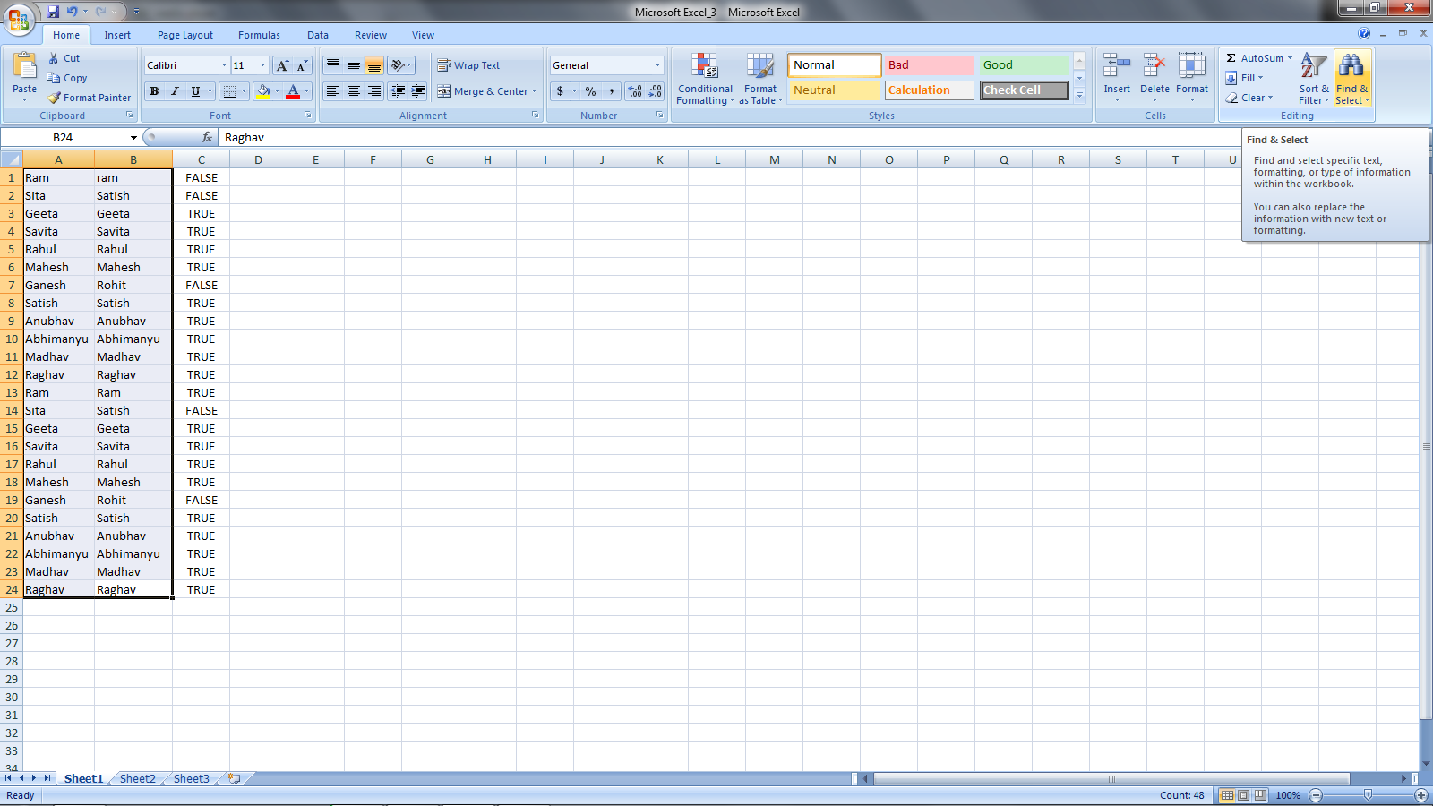
- ‘Go to special’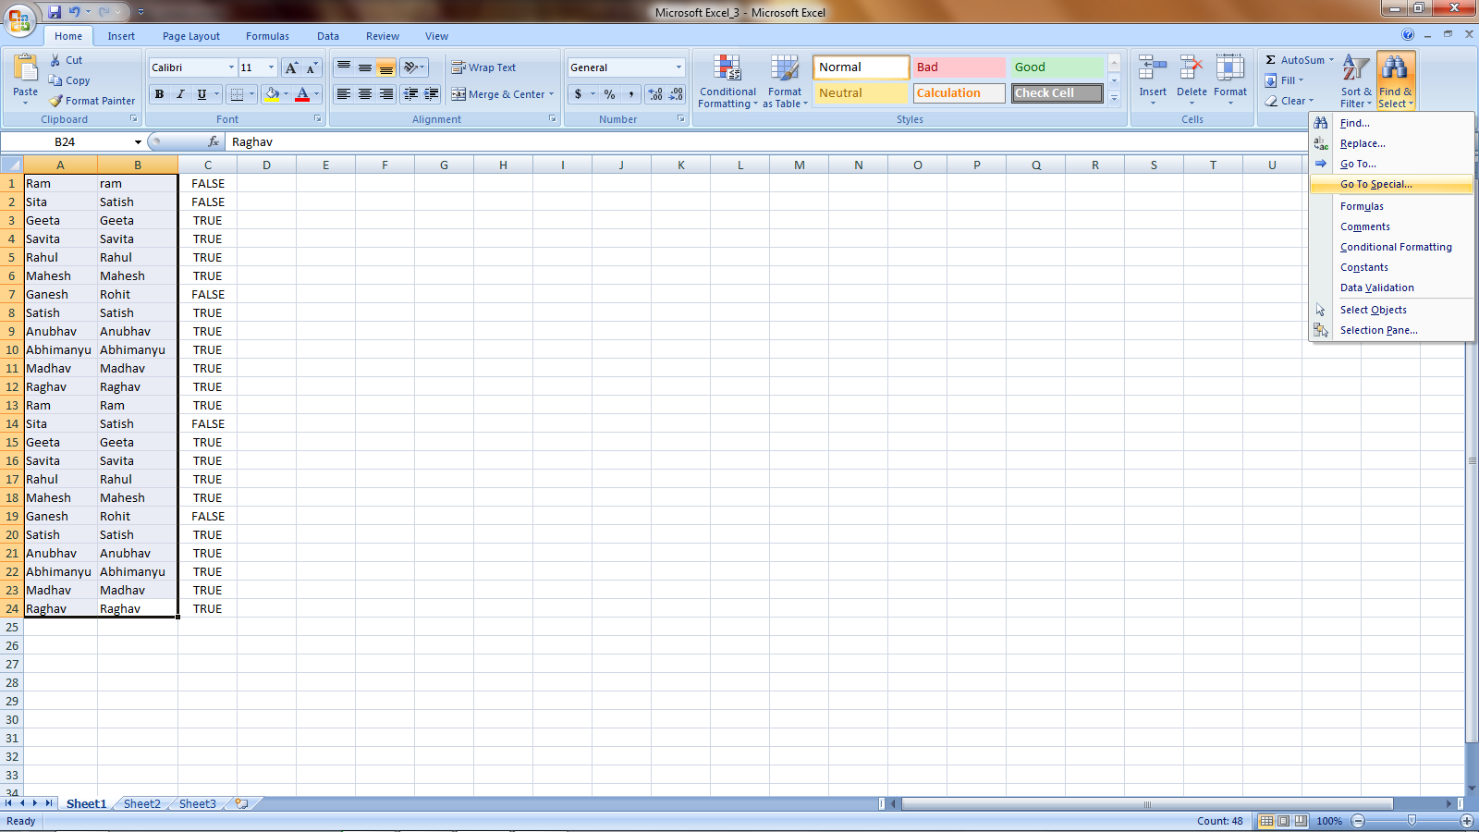
- Select ‘Raw Difference’ and click ‘OK’ Odd ones are highlighted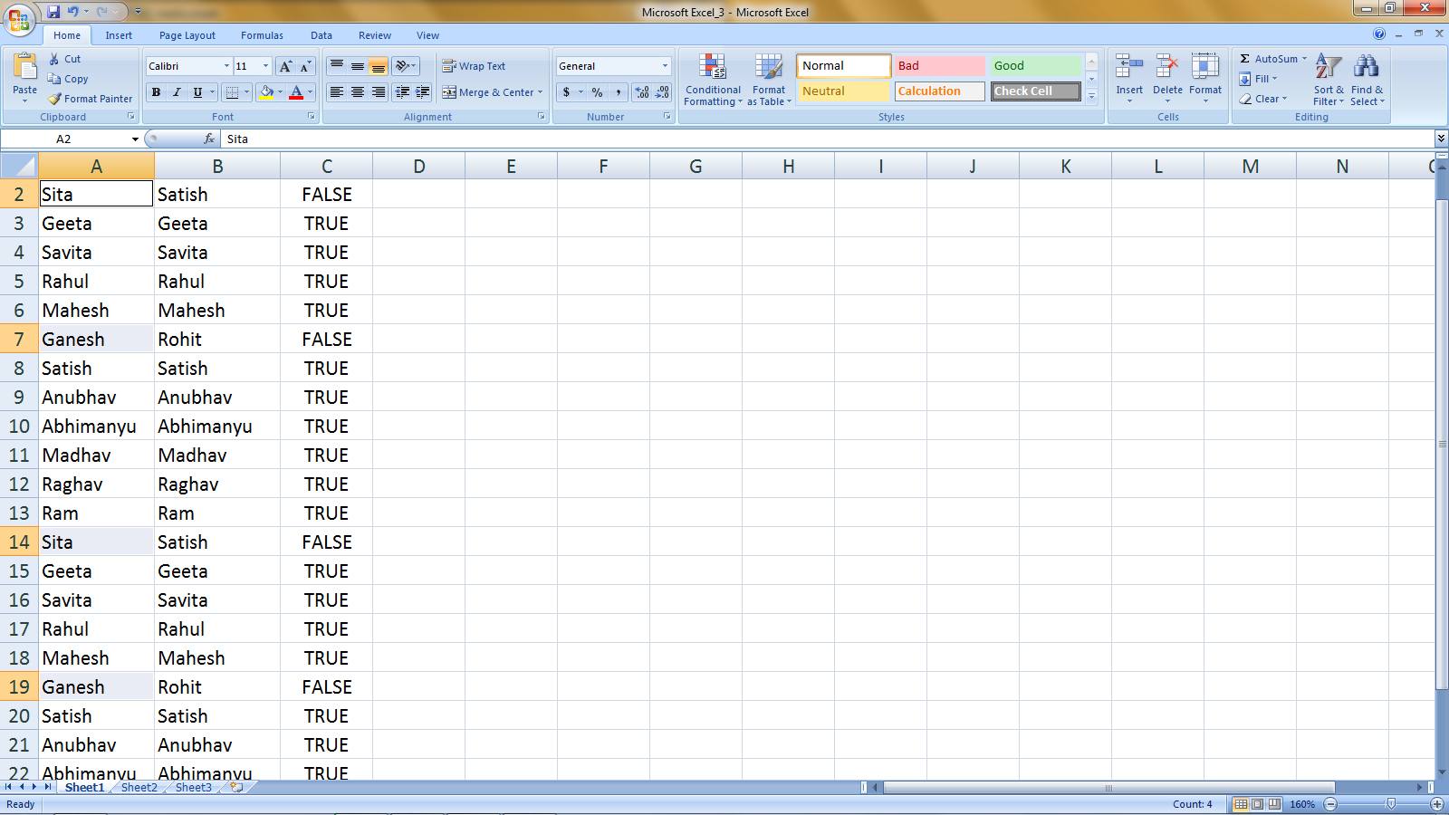
- Click on ‘fill color’ to get your selected items in different colors 